**Poject creating a transit gateway and connecting one vpc to another vpc using terraform**

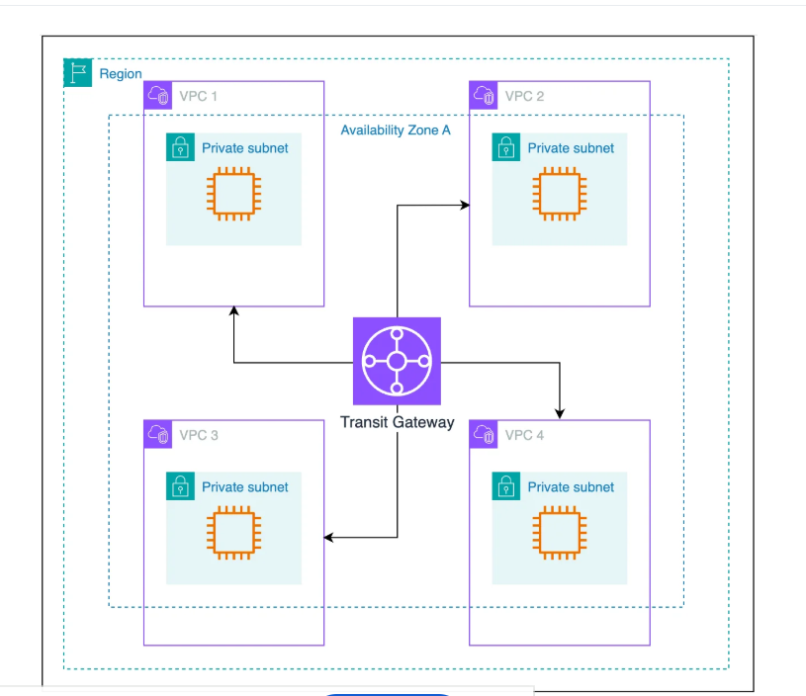

**##Creating VPc**

**resource "aws_vpc" "aprilvpc" {**

**cidr_block = "10.0.0.0/16"**

**tags = {**

**Name = "myvpc"**

**}**

**}**

**### creating public subnet**

**resource "aws_subnet" "public-sub" {**

**vpc_id = aws_vpc.aprilvpc.id**

**availability_zone = "eu-north-1a"**

**cidr_block = "10.0.1.0/24"**

**tags = {**

**Name = "publicsubnet"**

**}**

**}**

**## creating private subnet**

**resource "aws_subnet" "private-sub" {**

**vpc_id = aws_vpc.aprilvpc.id**

**availability_zone = "eu-north-1b"**

**cidr_block = "10.0.2.0/24"**

**tags = {**

**Name = "privatesubnet"**

**}**

**}**

**### Creating internet gateway**

**resource "aws_internet_gateway" "mygate" {**

**vpc_id = aws_vpc.aprilvpc.id**

**tags = {**

**Name = "myinternaetgateway"**

**}**

**}**

**## creating public route-table**

**resource "aws_route_table" "public-route" {**

**vpc_id = aws_vpc.aprilvpc.id**

**tags = {**

**Name = "public-route-table"**

**}**

**}**

**## creating private route-tble**

**resource "aws_route_table" "private-route" {**

**vpc_id = aws_vpc.aprilvpc.id**

**tags = {**

**Name = "private-route-table"**

**}**

**}**

**### adding internet-gateway to public-route table**

**resource "aws_route" "internet_route" {**

**route_table_id = aws_route_table.public-route.id**

**destination_cidr_block = "0.0.0.0/0"**

**gateway_id = aws_internet_gateway.mygate.id**

**}**

**## adding public-subnets to public route table**

**resource "aws_route_table_association" "pub-ass" {**

**subnet_id = aws_subnet.public-sub.id**

**route_table_id = aws_route_table.public-route.id**

**}**

**### adding private-subnets to private route table**

**resource "aws_route_table_association" "private-ass" {**

**subnet_id = aws_subnet.private-sub.id**

**route_table_id = aws_route_table.private-route.id**

**}**

**##creating elastic ip**

**resource "aws_eip" "elasticip" {**

**domain = "vpc"**

**}**

**##creating a natgateway**

**resource "aws_nat_gateway" "natgateway" {**

**subnet_id = aws_subnet.public-sub.id**

**allocation_id = aws_eip.elasticip.id**

**connectivity_type = "public"**

**tags = {**

**Name = "mynatgateway"**

**}**

**}**

**##adding natgateway into private route table**

**resource "aws_route" "private-route" {**

**route_table_id = aws_route_table.private-route.id**

**destination_cidr_block = "0.0.0.0/0"**

**nat_gateway_id = aws_nat_gateway.natgateway.id**

**}**

**## Creating public server**

**resource "aws_instance" "public" {**

**ami = "ami-0274f4b62b6ae3bd5"**

**instance_type = "t3.micro"**

**subnet_id = aws_subnet.public-sub.id**

**associate_public_ip_address = true**

**key_name = "NewKEY"**

**user_data = <<-EOF**

**#!/bin/bash**

**sudo su -**

**yum install httpd -y**

**cd /var/www/html**

**touch index.html**

**echo "<h1> this is public ec2<h1>" >> index.html**

**EOF**

**tags = {**

**Nmae = "public-server"**

**}**

**}**

**##creating private subnet**

**resource "aws_instance" "private" {**

**ami = "ami-0274f4b62b6ae3bd5"**

**instance_type = "t3.micro"**

**subnet_id = aws_subnet.private-sub.id**

**key_name = "NewKEY"**

**user_data = <<-EOF**

**#!/bin/bash**

**sudo su -**

**yum install httpd -y**

**cd /var/www/html**

**touch index.html**

**echo "<h1> this is private ec2<h1>" >> index.html**

**EOF**

**tags = {**

**Nmae = "private-server"**

**}**

**}**

**## creating security group for aws ec2 endpoint**

**resource "aws_security_group" "endpoint" {**

**name ="endpoit-sg"**

**description = "allowing all tarffic"**

**vpc_id = aws_vpc.aprilvpc.id**

**egress {**

**from_port = 0**

**to_port = 0**

**protocol = "-1"**

**cidr_blocks = ["0.0.0.0/0"]**

**}**

**tags = {**

**name = "endpont-securiy"**

**}**

**}**

**## creating private server**

**resource "aws_ec2_instance_connect_endpoint" "myinstant" {**

**subnet_id = aws_subnet.private-sub.id**

**security_group_ids = [aws_security_group.endpoint.id]**

**tags = {**

**Name = "ec2-endpoint"**

**}**

**}**

**##Creating tansit gateway**

**resource "aws_ec2_transit_gateway" "tramsit-gw" {**

**description = "connecting one vpc to another vpc "**

**tags = {**

**Name = "trasit-gateway"**

**}**

**}**

**##creating a transit attechment**

**resource "aws_ec2_transit_gateway_vpc_attachment" "vpc1" {**

**transit_gateway_id = aws_ec2_transit_gateway.tramsit-gw.id**

**vpc_id = aws_vpc.aprilvpc.id**

**subnet_ids = [**

**aws_subnet.private-sub.id,**

**aws_subnet.public-sub.id**

**]**

**tags = {**

**name = "vpc1-attachnebt"**

**}**

**}**

**#### adding transit-gateway into public-router**

**resource "aws_route" "adding-tarnsit" {**

**route_table_id = aws_route_table.public-route.id**

**destination_cidr_block = "192.168.0.0/16"**

**transit_gateway_id = aws_ec2_transit_gateway.tramsit-gw.id**

**}**

**## adding transit-gateway into private-router**

**resource "aws_route" "adding-tarnsit1" {**

**route_table_id = aws_route_table.private-route.id**

**destination_cidr_block = "192.168.0.0/16"**

**transit_gateway_id = aws_ec2_transit_gateway.tramsit-gw.id**

**}**

**Creating vpc 2**

**#creating another vpc**

**resource "aws_vpc" "dilipvpc" {**

**cidr_block = "192.168.0.0/16"**

**instance_tenancy = "default"**

**enable_dns_hostnames = true**

**enable_dns_support = true**

**}**

**##creating public subnet**

**resource "aws_subnet" "public-sub1" {**

**vpc_id = aws_vpc.dilipvpc.id**

**availability_zone = "eu-north-1a"**

**cidr_block = "192.168.1.0/24"**

**tags = {**

**name = "dilip-public"**

**}**

**## creating private subnet**

**}**

**resource "aws_subnet" "private-sub1" {**

**vpc_id = aws_aws.dilipvpc.vpc_id**

**availability_zone = "eu-north-1b"**

**cidr_block = "192.168.2.0/24"**

**tags = {**

**name = "dilip-private"**

**}**

**}**

**##create a public-route**

**resource "aws_route_table" "public-route1" {**

**vpc_id = aws_vpc.dilipvpc.id**

**tags = {**

**name = "dilip-public"**

**}**

**}**

**##creating private route table**

**resource "aws_route_table" "private-route1" {**

**vpc_id = aws_vpc.dilipvpc.id**

**tags = {**

**name = "dilip-private"**

**}**

**}**

**##creating a internet-gatway**

**resource "aws_internet_gateway" "internet-gateway" {**

**vpc_id = aws_vpc.dilipvpc.id**

**tags = {**

**name = "dilip-internet-gateway"**

**}**

**}**

**## adding public-subnet to public-route table**

**resource "aws_route_table_association" "public-ass" {**

**route_table_id = aws_route_table.private-route1.id**

**subnet_id = aws_subnet.public-sub1.id**

**}**

**## adding private-subnet to private-route table**

**resource "aws_route_table_association" "private-ass" {**

**route_table_id = aws_route_table.private-route1.id**

**subnet_id = aws_subnet.private-sub1**

**}**

**## creating internet-gateway**

**resource "aws_route" "internet-igw" {**

**route_table_id = aws_route_table.public-route1**

**destination_cidr_block = "0.0.0.0/0"**

**gateway_id = aws_internet_gateway.internet-gateway.id**

**}**

**## creating elastic-ip**

**resource "aws_eip" "elastic-ip1" {**

**domain = "vpc"**

**}**

**##creating nat-gateway**

**resource "aws_nat_gateway" "mynat1" {**

**subnet_id = aws_subnet.public-sub1.id**

**connectivity_type = "public"**

**allocation_id = aws_eip.elastic-ip1.id**

**tags = {**

**namec= "dilipnat"**

**}**

**}**

**##add nat into private-route-table**

**resource "aws_route" "nat-ass" {**

**route_table_id = aws_route_table.private-route1.id**

**destination_cidr_block = "0.0.0.0/0"**

**nat_gateway_id = aws_nat_gateway.mynat1.id**

**}**

**##creating security-group**

**resource "aws_security_group" "endpoint1" {**

**name = "dilip-end"**

**description = "allowing-all-traffic-outbound"**

**vpc_id = aws_vpc.dilipvpc.id**

**ingress {**

**description = "all-ports"**

**from_port = "0"**

**to_port = "0"**

**protocol = "-1"**

**cidr_blocks = ["0.0.0.0/0"]**

**}**

**}**

**### creating endpoint to connect private ec2**

**resource "aws_ec2_instance_connect_endpoint" "endpont1" {**

**vpc_id = aws_vpc.dilipvpc.id**

**subnet_id = aws_subnet.private-sub1.id**

**security_group_ids = aws_security_group.endpoint1.id**

**tags = {**

**name = "dilip-endpoint"**

**}**

**}**

**## creating transit-attachment**

**resource "aws_ec2_transit_gateway_vpc_attachment" "vpc-att1" {**

**transit_gateway_id = aws_ec2_transit_gateway.tramsit-gw.id**

**vpc_id = aws_vpc.dilipvpc.id**

**subnet_ids = [**

**aws_subnet.public-sub1,**

**aws_subnet.private-sub1**

**]**

**tags = {**

**name = "dilip-transit"**

**}**

**}**

**resource "aws_instance" "public1" {**

**ami = "ami-0274f4b62b6ae3bd5"**

**instance_type = "t3.micro"**

**subnet_id = aws_subnet.public-sub1**

**associate_public_ip_address = true**

**key_name = "NewKEY"**

**user_data = <<-EOF**

**#!/bin/bash**

**sudo su -**

**yum install httpd -y**

**cd /var/www/html**

**touch index.html**

**echo "<h1> this is public ec2<h1>" >> index.html**

**EOF**

**tags = {**

**Nmae = "public-server"**

**}**

**}**

**resource "aws_instance" "privat1" {**

**ami = "ami-0274f4b62b6ae3bd5"**

**instance_type = "t3.micro"**

**subnet_id = aws_subnet.private-sub1**

**key_name = "NewKEY"**

**user_data = <<-EOF**

**#!/bin/bash**

**sudo su -**

**yum install httpd -y**

**cd /var/www/html**

**touch index.html**

**echo "<h1> this is public ec2<h1>" >> index.html**

**EOF**

**tags = {**

**Nmae = "privat-subnet1"**

**}**

**}**

**resource "aws_route" "adding-tarnsit2" {**

**route_table_id = aws_route_table.public-route1.id**

**destination_cidr_block = "10.0.0.0/16"**

**transit_gateway_id = aws_ec2_transit_gateway.tramsit-gw.id**

**}**

**resource "aws_route" "adding-tarnsit4" {**

**route_table_id = aws_route_table.public-route1.id**

**destination_cidr_block = "10.0.0.0/16"**

**transit_gateway_id = aws_ec2_transit_gateway.tramsit-gw.id**

**}**

**OUTPUTS OS CODE**

**FOR VPC1**

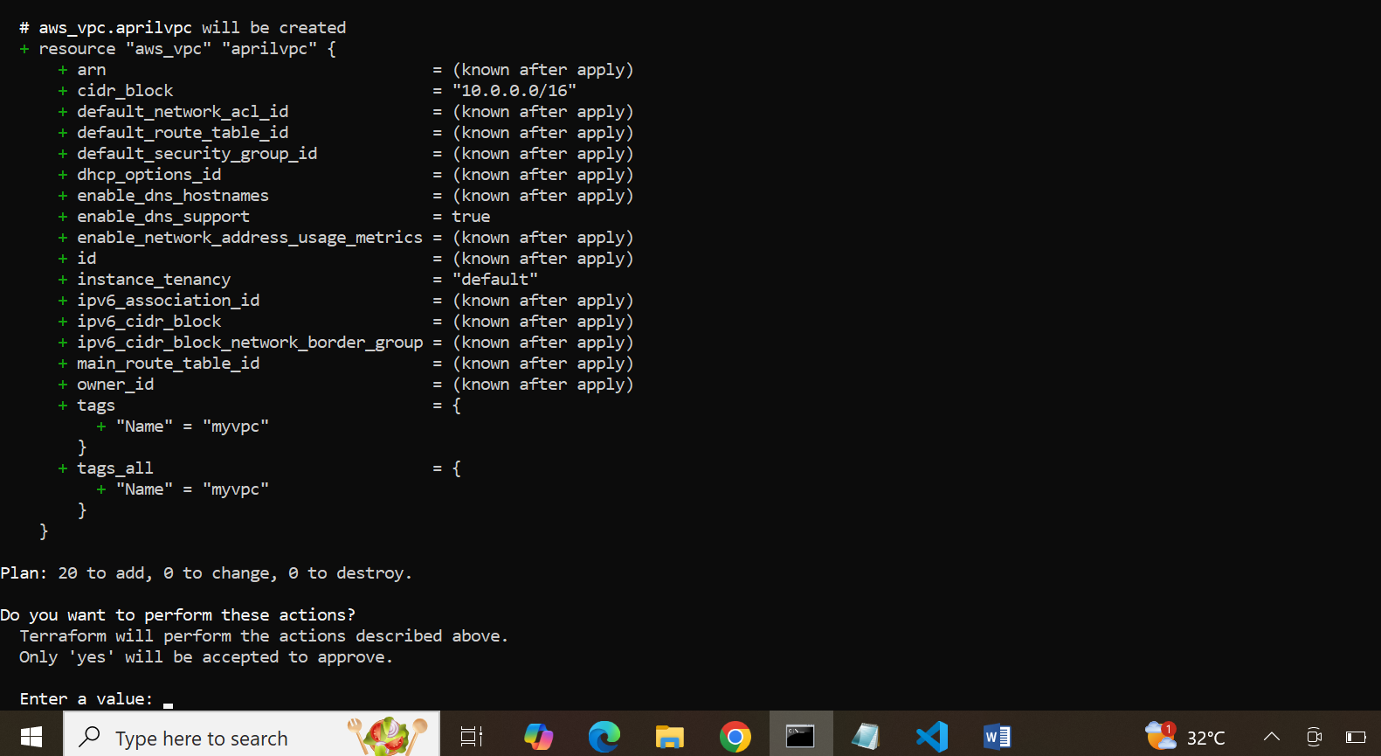

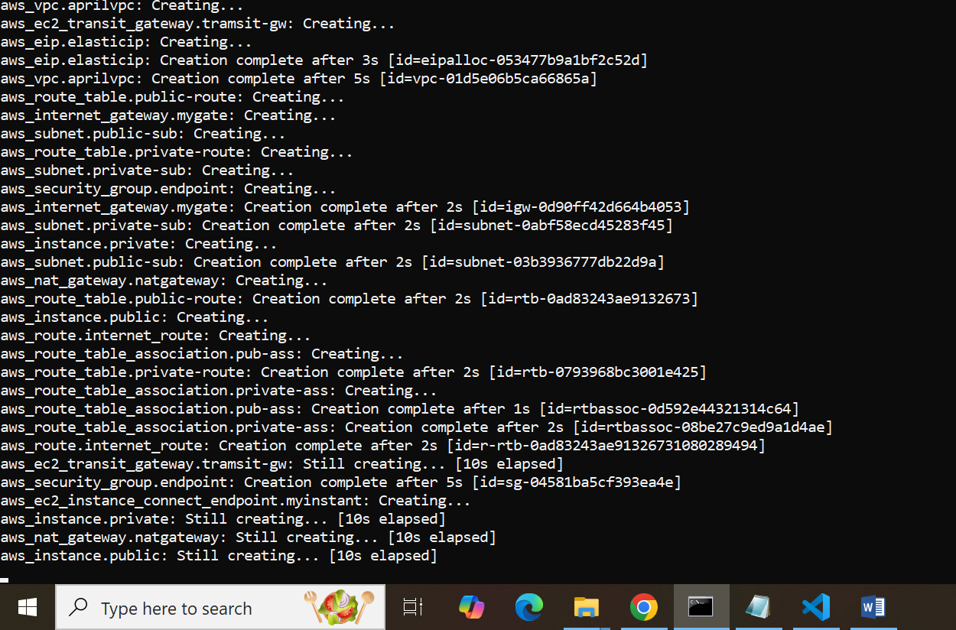

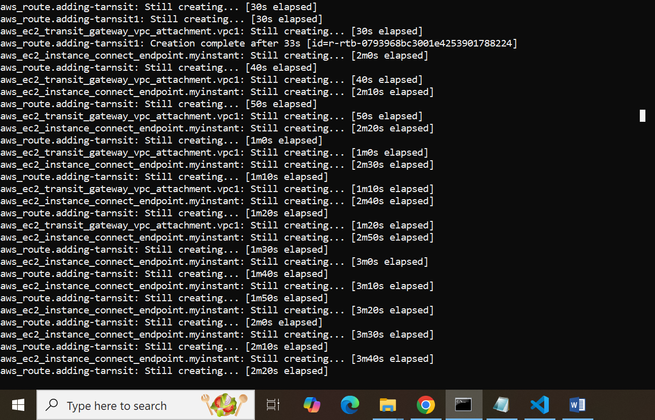

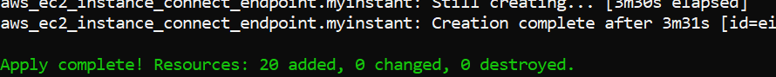

CONNECTING

VPC1 PUBLIC EC2 TO VPC2 PRIVATE EC2

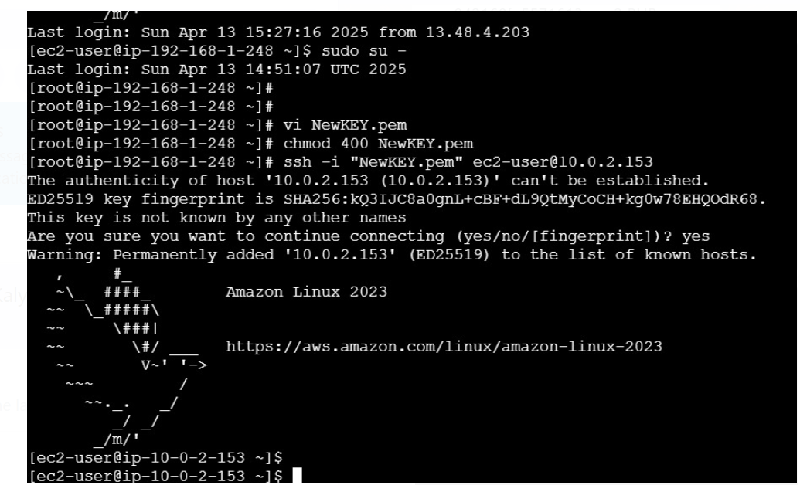

VPC1 PRIVATE EC2 TO VPC2 PRIVATE EC2

